January 16 2024

Main press contact
Leticia Jimenez Buil
Head of Market Communications
Comfort & Insulation
Interface & Performance
Phone + 49 201 173 3656
leticia.jimenez-buil@evonik.com

Alternative press contact
Katja Marx
Head of Market Communications
Specialty Additives
Phone +49 6181 59-13831
katja.marx@evonik.com

Evonik Industries AG
Rellinghauser Straße 1-11
45128 Essen
Germany
Phone +49 201 177-01
Fax +49 201 177-3475
www.evonik.com

Supervisory Board
Bernd Tönjes, Chairman
Executive Board
Christian Kullmann, Chairman
Dr. Harald Schwager, Deputy Chairman Maike Schuh, Thomas Wessel

Registered Office is Essen
Register Court Essen Local Court Commercial Registry B 19474

Evonik achieves ISCC PLUS sustainability certification for specialty chemicals production in Essen

- Third party sustainability accreditation for Essen Goldschmidt site for the substitution of raw materials
- Availability of certified products to start in the first half of 2024
- Latest site certification supports Evonik’s continued portfolio transformation to sustainable solutions

Essen, Germany. Evonik has attained the International Sustainability and Carbon Certification (ISCC) PLUS for its specialty chemicals production at the Essen Goldschmidt site. The certification is based on the mass balance approach, which ensures that sustainable feedstocks are used and that the supply chain is traceable.

The Essen Goldschmidt site follows other Evonik sites, such as Marl and Herne (Germany), and Mobile (Alabama, USA) to gain accreditation for its sustainable and fully traceable supply chains. The increasing move away from fossil-based raw materials is part of the Evonik Next Generation Solutions sustainability strategy, which focuses on portfolio and innovation management, production and technology.

“As an innovation frontrunner in specialty markets, we strive to offer both excellent product performance and sustainability leadership. Thanks to the ISCC PLUS certification for the production of specialty chemicals such as our surfactants at the Goldschmidt site in Essen, our customers from coatings and inks to adhesives, polyurethane foams and personal care will have access to a wider range of certified additives made from a higher proportion of renewable raw materials,” said Dr. Claudine Mollenkopf, head of the Specialty Additives division.

With the same performance profile and characteristics as their traditional counterparts, the new certified specialty chemicals, for instance surfactants, will help Evonik’s customers to reduce the use of fossil resources and improve the sustainability of their products, without any changes to production processes. By reducing its reliance on fossil-based raw materials, Evonik is lowering the carbon footprint of its own products and also supporting customers address their own sustainability, CO₂ reduction and environmental regulation demands.

Product scope from first half of 2024
The specialty chemicals, mainly surfactants, produced in the newly certified Essen Goldschmidt site are often used for cleansing, foaming, emulsifying and solubilizing purposes. They will include TEGOSTAB® additives for polyurethane foams for mattresses or insulation panels, TEGO® industrial coatings and inks, TEGOMER®, TAGAT® and TEGO® PE for industrial processes and further applications in agrochemistry and personal care.

Starting in the first half of this year, existing and new customers will have access to these certified surfactants containing a significant amount of mass balanced feedstock, and consequently a lower carbon footprint.

Mass balancing
In complex manufacturing systems such as chemical production, mass balancing allows manufacturers to mix certified and non-certified materials while keeping them separated administratively. This provides the transparency to track the amount of renewable material used and how it corresponds to the amount of certified content in the resulting products.

For a detailed explanation and video about the ISCC PLUS mass balance concept visit: https://corporate.evonik.com/en/sustainability/sustainability-analyses/mass-balance-approach

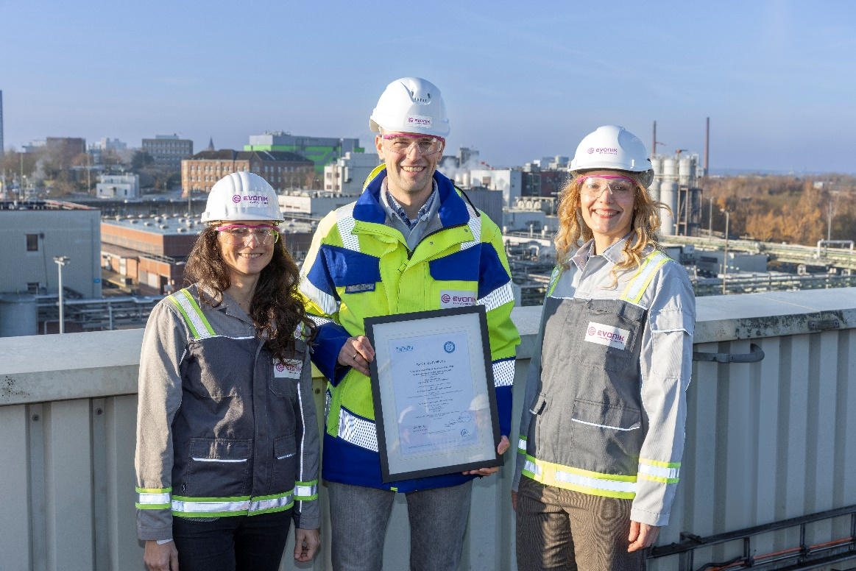
Sustainability faces from the Specialty Additives division: (left to right) Dr. Marta Canas Ventura, Sustainability Manager at Interface & Performance, Tim-Frederic Sloot, Head of Sustainability at Coating Additives, and Dr. Gesa Behnken, Global Marketing Director Insulation at Comfort & Insulation.

About Evonik

Evonik is one of the world leaders in specialty chemicals. The company is active in more than 100 countries around the world and generated sales of €18.5 billion and an operating profit (adjusted EBITDA) of €2.49 billion in 2022. Evonik goes far beyond chemistry to create innovative, profitable, and sustainable solutions for customers. About 34,000 employees work together for a common purpose: We want to improve life today and tomorrow.

About Specialty Additives

The Specialty Additives division combines the businesses of versatile additives and high-performance crosslinkers. They make end products more valuable, more durable, save more energy and simply better. As formulation experts in fast growing markets such as coatings, mobility, infrastructure and consumer goods, Specialty Additives combines a small amount with a big effect. With its 3,800 employees the division generated sales of €4.18 billion in 2022.

Disclaimer

In so far as forecasts or expectations are expressed in this press release or where our statements concern the future, these forecasts, expectations or statements may involve known or unknown risks and uncertainties. Actual results or developments may vary, depending on changes in the operating environment. Neither Evonik Industries AG nor its group companies assume an obligation to update the forecasts, expectations or statements contained in this release.

